
RAJALAKSHMI INSTITUTE OF TECHNOLOGY
(An Autonomous Institution, Affiliated to Anna University, Chennai)

DEPARTMENT OF ARTIFICIAL INTELLIGENCE AND DATA SCIENCE
ACADEMIC YEAR 2025 - 2026
SEMESTER IV
AL23421 - MACHINE LEARNING LABORATORY
MINI PROJECT REPORT

REGISTER NUMBER | 2117240070306
NAME | SHYLENDHAR M
PROJECT TITLE | Cluster Vision
DATE OF SUBMISSION
FACULTY IN-CHARGE | MS. Fouzia Sulthana K

Signature of Faculty In-charge Signature of HoD

Internal Examiner External Examiner
INTRODUCTION
- The application is built as a full-stack web platform, combining a Python-based machine learning pipeline with a Node.js/Express backend and an interactive frontend dashboard. This architecture enables users to execute the clustering model, visualize customer segments in real-time, and derive actionable insights through an intuitive graphical interface.
- By bridging machine learning with accessible visualization, this project demonstrates how businesses can transform raw customer data into strategic segmentation insights without requiring specialized technical expertise.
PROBLEM STATEMENT
- Businesses today collect vast amounts of customer data but struggle to extract actionable insights from it. Without proper segmentation, companies resort to one-size-fits-all marketing strategies that fail to address the diverse needs, preferences, and purchasing behaviours of different customer groups. This leads to inefficient resource allocation, poor customer engagement, and lost revenue opportunities.
GOAL
- To develop an automated, interactive customer segmentation system that uses K-Means clustering with Silhouette Score optimization to discover optimal customer groups and visualize them through a user-friendly web dashboard—enabling businesses to derive actionable insights from customer data without requiring machine learning expertise
THEORETICAL BACKGROUND
Customer Segmentation
  - Customer segmentation is the process of dividing a customer base into distinct groups based on shared characteristics. This enables businesses to tailor strategies to each group's specific needs rather than using ineffective one-size-fits-all approaches.
K-Means Clustering
- K-Means is an unsupervised learning algorithm that partitions data into K clusters by minimizing the distance between data points and their assigned cluster centroids. The algorithm iteratively assigns points to the nearest centroid and recalculates centroids until convergence. Its objective is to minimize the Within-Cluster Sum of Squares (WCSS):

- $$\text{WCSS} = \sum_{i=1}^{K} \sum_{x \in C_i} ||x - \mu_i||^2$$
Silhouette Score Optimization

- Since K-Means requires K to be specified in advance, this project uses the Silhouette Score to automatically find the optimal number of clusters. The score ranges from -1 to +1, where higher values indicate well-defined, well-separated clusters. The algorithm evaluates K from 2 to 9 and selects the value that maximizes this score.
Feature Selection
- The model uses two features:
  - Annual Income (k$) — purchasing power
  - Spending Score (1-100) — customer engagement/loyalty
These dimensions reveal meaningful segments such as high-value customers, underspent high-earners, and price-sensitive buyers.
ALGORITHM EXPLANATION WITH EXAMPLE
K-Means Clustering
- How K-Means Works:
  - Choose K: Specify the number of clusters (K)
  - Initialize: Randomly pick K data points as initial centroids
  - Assign: Calculate the distance from each point to all centroids and assign it to the nearest one
  - Update: Recalculate each centroid as the mean of all points assigned to it
  - Repeat: Steps 3 and 4 until centroids no longer change significantly or max iterations reached
Example
Consider 8 customers based on Annual Income (k$) and Spending Score:

│ Customer │ Income (k$) │ Spending Score │
│ A │ 15 │ 39 │
│ B │ 15 │ 81 │
│ C │ 86 │ 4 │
│ D │ 87 │ 6 │
│ E │ 25 │ 77 │
│ F │ 88 │ 5 │
│ G │ 15 │ 76 │
│ H │ 85 │ 8 │

Step 1: Let K = 2. Randomly pick centroids: C(86, 4) and E(25, 77)
Step 2: Assign each customer to nearest centroid:
- Cluster 1 → C, D, F, H (High Income, Low Spending)
- Cluster 2 → A, B, E, G (Low Income, High Spending)
Step 3: Recalculate centroids:
- New centroid 1 = mean of (86, 4), (87, 6), (88, 5), (85, 8) = (86.5, 5.75)
- New centroid 2 = mean of (15, 39), (15, 81), (25, 77), (15, 76) = (17.5, 68.25)
Step 4: Reassign points. If no points change clusters, the algorithm converges. Otherwise, repeat steps 2–4.
Silhouette Score in This Project
- Instead of manually choosing K, this project tests K = 2 to 9, computes the Silhouette Score for each, and selects the K with the highest score. In the
- Mall Customers dataset, the optimal K is typically 5, revealing segments like:
  - Careful Customers
  - Standard Customers
  - Target Customers
  - Sensible Customers
  - Careless Customers
IMPLEMENTATION CODE AND DATASET USED
- Dataset Used – Link of the dataset, Explain the complete specification of the dataset
Category | Description / Example
Dataset Name | Mall_Customers.csv
Domain | e.g., Marketing, Sales Analysis
Objective | Classification / Clustering
Data Source | Public
Number of Samples | 201
Data Type | Text
Instance Description | Customer’s product selection and price
Features (Inputs) | Annual Income(k), Spending Score(1 to k-1)
Feature Types | Numerical / Numerical
Target Variable | Cluster label generated by the algorithm
Number of Classes | 5
License | ISC
Version | 1.0.0
- Python code

import pandas as pd
from sklearn.cluster import KMeans
from sklearn.metrics import silhouette_score
import os

# Load dataset
df = pd.read_csv("dataset/Mall_Customers.csv")
X = df[['Annual Income (k$)', 'Spending Score (1-100)']]

# Find optimal K using Silhouette Score
best_k = 2
best_score = -1

for k in range(2, 10):
kmeans = KMeans(n_clusters=k, random_state=42)
labels = kmeans.fit_predict(X)
score = silhouette_score(X, labels)
if score > best_score:
best_k = k
best_score = score

# Final clustering
kmeans = KMeans(n_clusters=best_k, random_state=42)
df['Cluster'] = kmeans.fit_predict(X)

# Save results
df.to_json("backend/data.json", orient='records')
print(f"Clustering complete. Optimal clusters: {best_k}")
OUTPUT
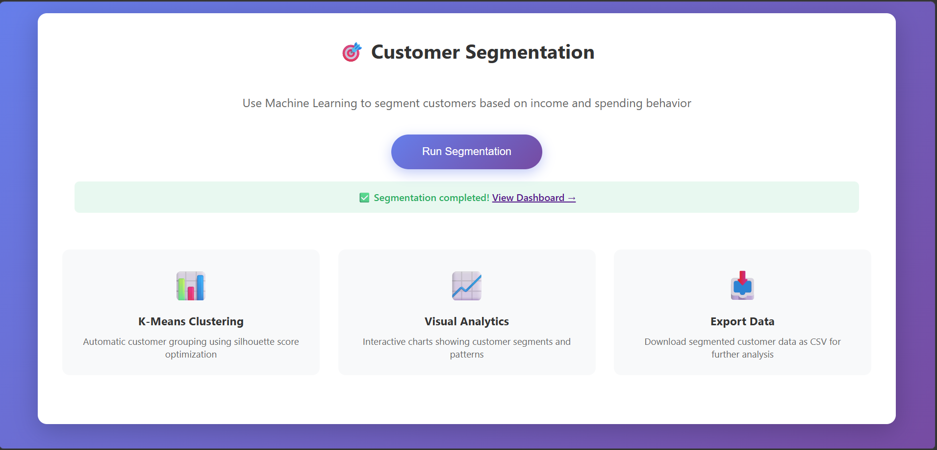
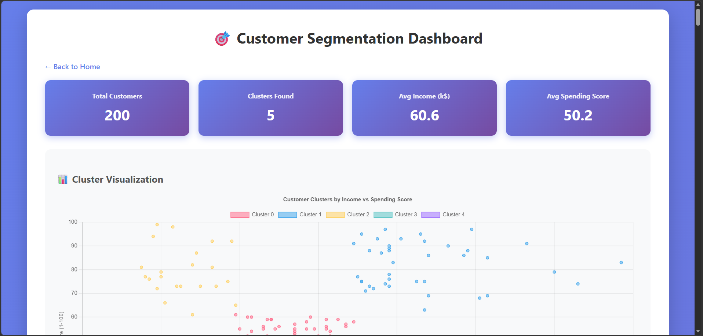
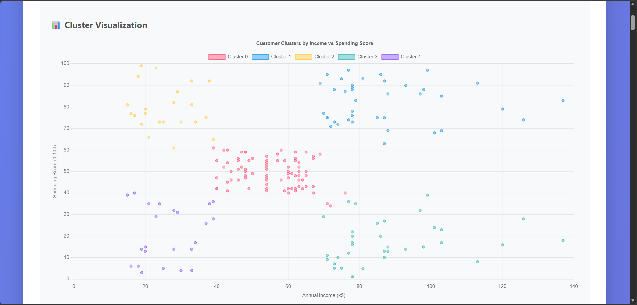

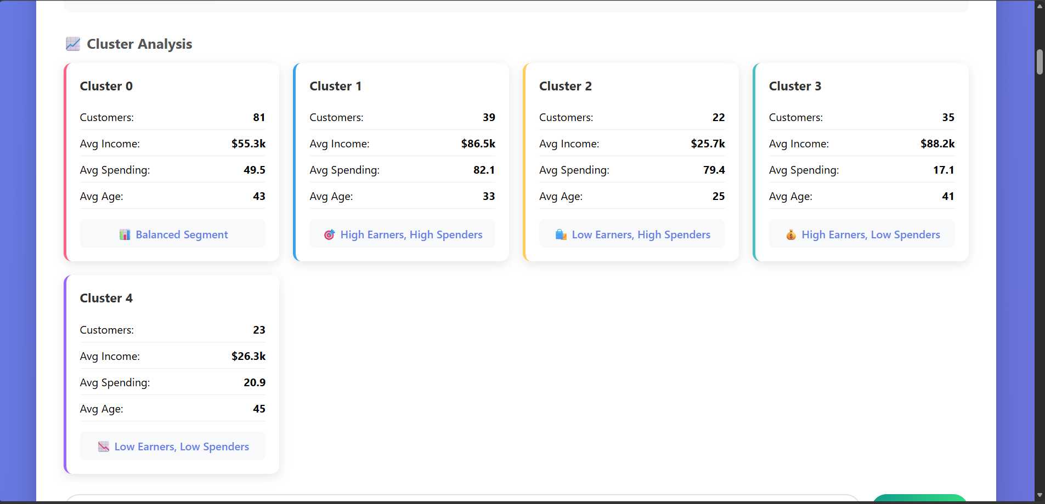
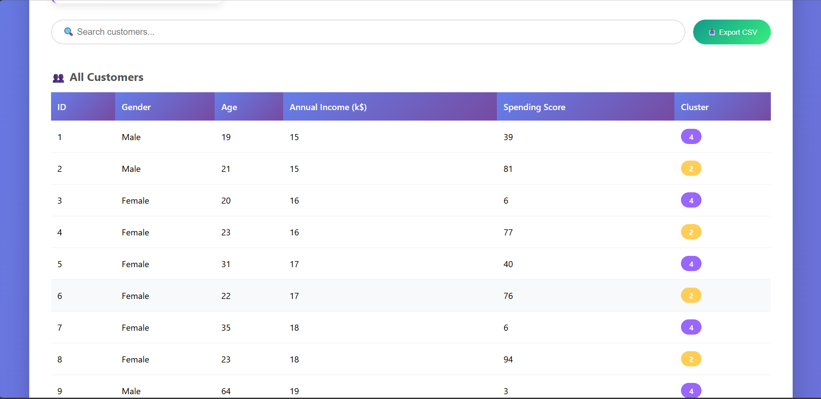
RESULTS AND FUTURE ENHANCEMENT
- The K-Means clustering model was applied to the Mall Customers dataset containing 200 customer records.
- The Silhouette Score optimization evaluated cluster counts from K = 2 to 9 and identified the optimal number of clusters as K = 5, achieving the highest silhouette score.
Cluster Distribution
The algorithm successfully segmented customers into 5 distinct groups:
Cluster | Typical Profile | Interpretation
0 | Average Income, Average Spending | Standard Customers
1 | High Income, High Spending | Valuable / Target Customers
2 | Low Income, High Spending | Careless / Impulsive Spenders
3 | Low Income, Low Spending | Sensible / Budget-Conscious
4 | High Income, Low Spending | Careful / Savvy Savers
Key Findings
  - The model automatically determined 5 optimal clusters without manual intervention
  - The visualization revealed clear separation between customer groups based on income and spending behavior
  - Businesses can use these segments to design targeted marketing campaigns, loyalty programs, and personalized offers for each customer group.
Cluster | Typical Profile | Interpretation
0 | Average Income, Average Spending | Standard Customers
1 | High Income, High Spending | Valuable / Target Customers
2 | Low Income, High Spending | Careless / Impulsive Spenders
3 | Low Income, Low Spending | Sensible / Budget-Conscious
4 | High Income, Low Spending | Careful / Savvy Savers

Git Hub Link of the project along with the report | https://github.com/shylendharm/ML-Customer-Segmentation.git

REFERENCES

- Scikit-Learn Documentation: Comprehensive guide on the KMeans algorithm and silhouette_score metric implementation.
- Pandas Documentation: Official resource for data manipulation, CSV handling, and JSON serialization using Python.
- Kaggle Datasets: Source for the "Mall Customers" CSV, providing the demographic and behavioral data used for training.

- UCI Machine Learning Repository: Standard academic reference for clustering datasets and benchmarking unsupervised learning models.
- StatQuest with Josh Starmer: Technical video resource explaining the mathematical intuition behind K-Means and the WCSS objective function.

